**WORK INSTRUCTIONS FOR OPERATING BF2 DUST EXTRACTION UNIT & BAG HOUSE**

Responsibility: Cast house in charge/ Control room in charge / Utility in charge

Identified Hazards:

1. Contact with lime powder, graphite dust

2. Contact with hot hood causing burns

3. Contact with dust, lime & fumes

4. Fire & explosion

5. Electric shock

6. Nonuse of PPE

7. Improper house keeping

8 Inadequate local lighting

9. Entrapment of person while unloading graphite from bags

10. Human error

Significant Aspect:

1. Emission of graphite

2. Consumption of compressed air

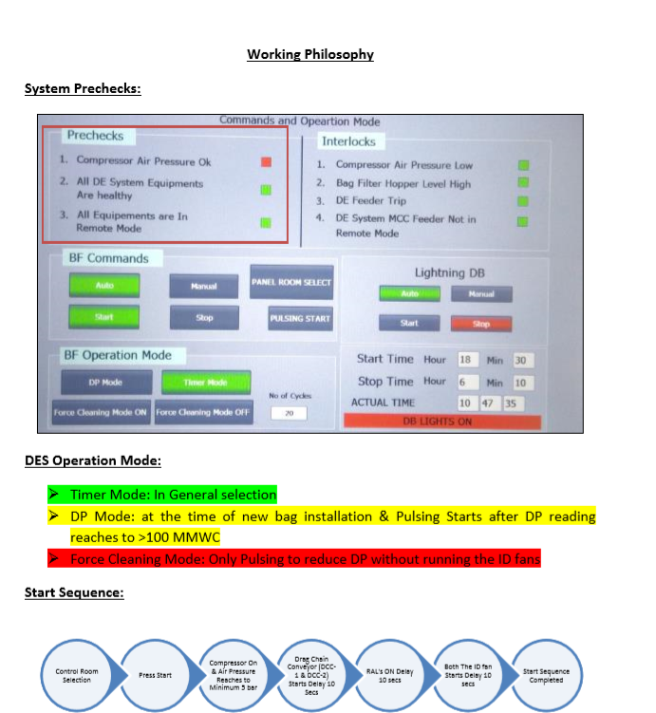

Sequence of operation

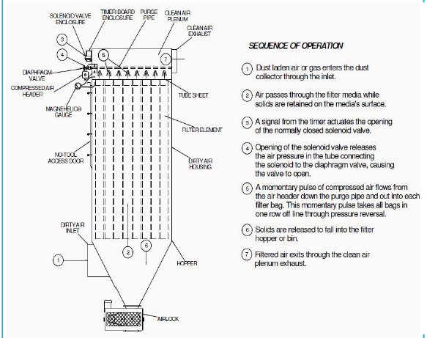

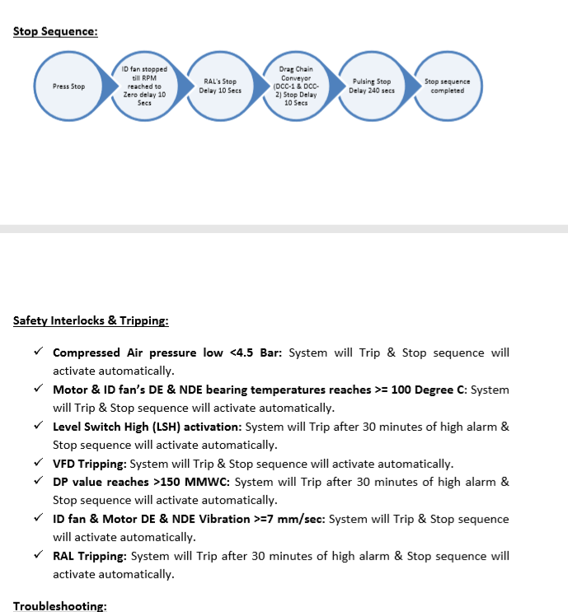

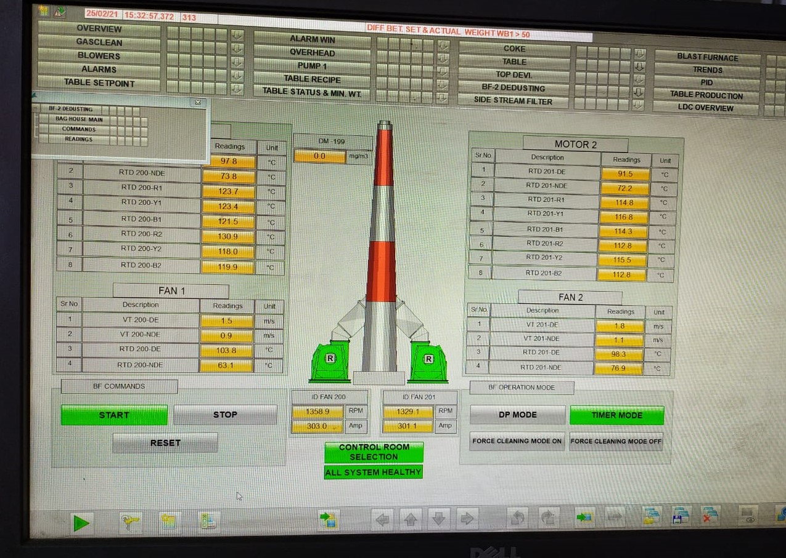

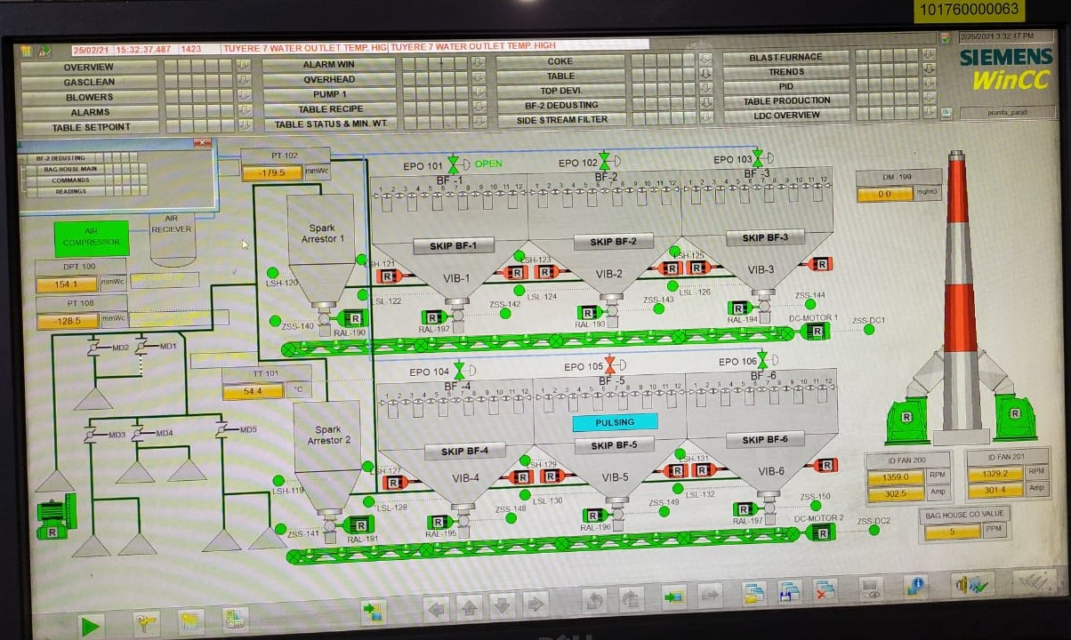

**Safety Interlocks & Tripping:**

**Compressed Air pressure low <4.S Bar:** System will Trip *&* Stop sequence will activate automatically.

**Motor & ID fan's DE & NOE bearing temperatures reaches >= 100°C:** System will Trip *&* Stop sequence will activate automatically.

**Level Switch High (LSH) activation:** System wi ll Trip after 30 minutes of high alarm *&*

Stop sequence will activate automatically.

*. / VFD* **Tripping:** System will Trip *&* Stop sequence will activate automatically.

*. /* **DP value reaches >150 MMWC:** System will Trip after 30 minutes of high alarm *&*

Stop sequence will activate automatically.

*. / ID* **fan & Motor DE & NOE Vibration >=7 mm/sec:** System will Trip *&* Stop sequence will activate automatically.

*. / RAL* **Tripping:** System will Trip after 30 minutes of high alarm *&* Stop sequence will activate automatically.

**Troubleshooting:**

**Level Switch High (LSH) Activate:**

* + Identify the LSH from P&ID or the MIMIC screen and check physically at site.

Rectify the same and re-start the system.

**VFD Tripped under Voltage Dip:**

* + Reset the VFO by pressing the reset button on VFO feeder panel and restart the system.

**Compressor not starting in Auto Mode after tripping or emergency push button on:**

* + Reset the compressor feeder in feeder panel and press the start button in compressor panel itself.

**Pulsing Pressure not maintained/ not ok:**

* + Check for any leakages through SOV's
  + Check individual headers for pressure sustenance and identify the header for SOV leakages id entification
  + Attend the leakages and restart the compressor. Any line leakages to attend to maintain pressure re.

**RAL's tripping:**

* + Check for jamming in RAL's
  + If yes. Clear the jam and restart the e system

**Drag Chain Conveyor (DCC) Jamming & Tripping:**

* + Check for jamming in DCC
  + If yes. Clear the jam and restart the system

|  |  |  |
| --- | --- | --- |
| Prepared By:  Head – Production PID I | Reviewed & Issued By:  Management Representative | Approved By:  Head – Pig Iron Division |
| Signature: | Signature: | Signature: |
| Date: 10.07.2023 | Date: 10.07.2023 | Date: 10.07.2023 |

|  |  |  |  |
| --- | --- | --- | --- |
| **Amendment Record** | | | |
| **Revision date** | **Manual Section ref. and para** | **Brief details of revision** | **New Revision No.** |
| 12.07.2021 | Procedure for SHUTDOWN OF BLAST FURNACE - II | Point no 7,20,35 | 14 |
| 15.07.2022 | Procedure for Shutdown of Blast Furnace -II | Change in format | 15 |